Spanning Tree Protocol – 802.1D, builds a layer 2 loop-free topology by temporarily blocking traffic on redundant ports. STP operates by selecting a specific switch as the master switch running a tree-based algorithm to identify which redundant ports should not forward traffic. By default, STP initialization time takes 30 seconds for a port to start forwarding the traffic.

STP Port States:

Disabled – port is ADM Shut.

Blocking – The switch port is enabled (UP) but is not forwarding any traffic to ensure that a loop is not created. Only receives BPDU from other switches.

Listening – transitioned from BLOCKING state and can now send and/or receive BPDUs but cannot forward any network traffic.

Learning – Switch port can now modify the mac address table with any network traffic it receives. Still does not forward any other network traffic besides BPDU.

Forwarding – switch port can now forward all network traffic and can update the mac address table. This is the final state.

Broken – the switch detected a configuration or operational problem on a port that can have major effects.

STP Port Types:

Root Port (RP) – A network port that connects to the root bridge or an upstream switch. One root port per Vlan on a switch.

Designated Port (DP) – A network port that receives and forwards BPDU frames to other switches. Provides connectivity to downstream switches. Only one active designated port of a link.

Blocking Port – A network that is not forwarding traffic due to STP calculations.

Other STP Terminologies:

Root Bridge – the most important switch in the layer 2 topology. Sometimes called the ROOT SWITCH. All ports of root bridge are forwarding state and/is a DESIGNATED PORT.

Bridge Protocol Data Unit (BPDU) – packed is used for network switches to identify the hierarchy and notify the changes in the STP topology. BDPU mac address is 01:80:c2:00:00:00.

Root path cost – combined cost for a specific path towards the ROOT SWITCH.

System Priority – A CONFIGURABLE VALUE that Indicates the preference for a switch to become the ROOT SWITCH. Default value is 32768. LOWER PRIORITY VALUE IS PREFERRED. VALUE OF 1 to 4096 can be used.

System ID – combination of the SYSTEM PRIORITY and the 12-bit value the indicates the VLAN ID.

Root Bridge ID – Combination of the MAC ADDRESS and the SYSTEM PRIORITY of the ROOT SWITCH.

Local Bridge ID – combination of LOCAL SWITCH meaning it is not the root switch, MAC ADDRESS, SYSTEM ID AND SYSTEM PRIORITY.

Max Age – CONFIGURABLE VALUE, the maximum amount of time the port saves the BPDU configuration once the switch loses contact with BPDU. Default value is 20 but can be changed from 6 to 40 seconds.

Hello Time – CONFIGURABLE VALUE, the time that a BPDU is advertised out of a port. Default value is 2 seconds but can be changed from 1 to 10 seconds.

Forward Delay – CONFIGURABLE VALUE, Amount of time a port stays in LISTENING STATE AND LEARNING STATE meaning before it starts to forward a network traffic. Default value is 15 seconds but can be changed from 15 to 30 seconds.

STP Cost Per Link Speed

10Mbps – 100 – 2M

100Mbps – 19 – 200K

1Gbps – 4 – 20k

10Gbps – 2 – 2k

20Gbps – 1 – 1k

100Gbps – 1 – 200

1Tbps – 1 – 20

10Tbps – 1 – 2

Building the STP Topology

STP LAB 1:

Initial Configurations for the switches:

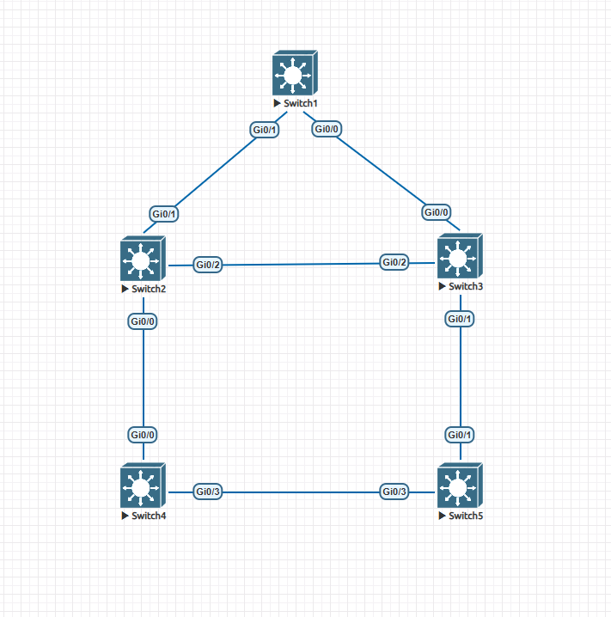

1. Create Vlan1, Vlan10, Vlan20, and Vlan99 on all the switches.
2. Set all ports to TRUNK PORT and allow all Vlans.

Locating the Root Bridge:

1. System Priority – by default all switches have the same priority which is the 32768 + the vlan ID number. If they have the same priority, it will choose the lowest MAC address.
2. MAC Address – All network devices have a unique MAC Address. Thus, it is impossible to have a tie in this election. Older switches have lower mac address by default.

To determine the ROOT Bridge on L2 Topology in Cisco:

*#show spanning-tree root*

*!the switch with a root cost of zero/0 is the ROOT SWITCH*

*#show spanning-tree <vlan-id>*

*!the output will show “THIS BRIDGE IS THE ROOT”*

***NOTES:***

***Older switches have LOWER mac address and is more preferred. You need to verify that information and perform necessary configuration when adding switch in a Layer 2 topology.***

Locating the Root Port:

1. **Lowest Path Cost – Path cost is determined by the link speed. The higher the link speed, the lower the cost.**
2. Interface associated with lowest system priority.
3. Interface associated to lowest mac address.
4. If links are going to the same switch, the lowest port priority.
5. **If links are going to the same switch, the lower port number is preferred.**

To Manipulate the cost of a port:

*#interface g0/X   
 #spanning-tree <vlan-id> cost <cost-value>*

To manipulate the Bridge ID of a Switch:

*#spanning-tree <vlan-id> priority <priority-value>*

***NOTES:***

***There is only one ROOT PORT on every local switch.***

***Root Port Manipulation can be performed through changing the priority of the switch or changing the root port cost of an interface.***

Locating the Designated Port:

1. Should not be a ROOT PORT.
2. Should be a port facing downstream switches.

Locating the Alternative/Blocking Port:

1. Should not be a ROOT PORT.
2. It is a port facing towards designated port and is not facing a downstream switch.

